Create a network for GNS3 VMS configured as followed:

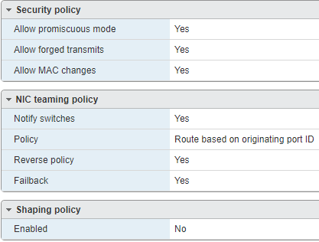

Go to <https://www.gns3.com/software/download-vm>

Chose VMware Workstation and Fusion download for the current version   
\*This will download a zip file with an OVA file

Use the OVA file to make one VM with the resources that you want allocated per 1 student/user

When you start the VM it should look like this 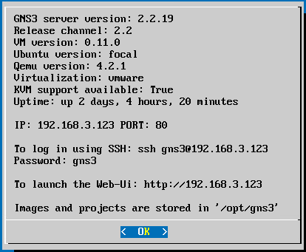

To set static networking hit enter or space to get to the menu

N to get to Network config file   
\*This will restart the VM after the file is saved

Network config files are pre-configured and commnted out for static configuration if desiered

Add appliance files to the VM threw direct download to the VM threw the Linux command line or through the GNS3 GUI

The ubuntu connsole can be accsesd with S

Then clone the VM or use it as a template for each student in the course